How Crash Testing Works  by Karim Nice  ››Tell a friend about this article! |  | › Introduction to How Crash Testing Works  › Crash Test Dummies  › An Actual Crash Test  › The "Perfect" Crash  › Future Safety Improvements  › Background and Ratings  › Lots More Information!  › Search Google  › Shop or Compare Prices  › What do you think?
Crash test dummies have been the subject of public service announcements, cartoons, parodies, even the name of a band. Real crash test dummies, however, are true life-savers as an integral part of automotive crash tests. Even though cars get a little safer each year, and fatality rates are declining, car crashes are still one of the leading causes of death and injury in the United States.
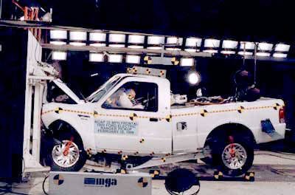
Photo courtesy NHTSA
One of the reasons cars have been getting safer is because of a well-established testing program. In this edition of HowStuffWorks, you'll learn all about automotive crash testing, including crash test programs, ratings, dummies and future improvements. You'll be amazed at how much thought and preparation goes into making sure that safe cars are on the roads!

Crash Test Dummies
The dummy's job is to simulate a human being during a crash, while collecting data that would not be possible to collect from a human occupant.
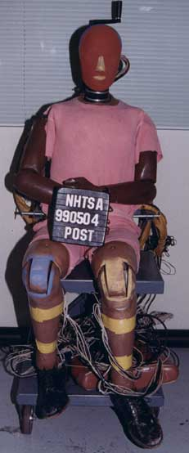
Photo courtesy NHTSA
All crash tests in the United States are conducted using the same type of dummy, the Hybrid III dummy. This guarantees consistent results. A dummy is built from materials that mimic the physiology of the human body. For example, it has a spine made from alternating layers of metal discs and rubber pads.
The dummies come in different sizes (click here to see some of the dummies), and they are referred to by percentile and gender. For example, the fiftieth-percentile male dummy represents the median sized male -- it is bigger than half the male population and smaller than the other half. This is the dummy most commonly used in crash testing. It weighs 172 lbs (78 kg) and is 69 inches (5 ft 9 inches or 1.75 m) tall.
The dummies contain three types of instrumentation:
- Accelerometers
- Load sensors
- Motion sensors
Accelerometers
These devices measure the acceleration in a particular direction. This data can be used to determine the probability of injury. Acceleration is the rate at which speed changes. For example, if you bang your head into a brick wall, the speed of your head changes very quickly (which can hurt!). But, if you bang your head into a pillow, the speed of your head changes more slowly as the pillow crushes (and it doesn't hurt!).
The crash-test dummy has accelerometers all over it. Inside the dummy's head, there is an accelerometer that measures the acceleration in all three directions (fore-aft, up-down, left-right). There are also accelerometers in the chest, pelvis, legs, feet and other parts of the body.
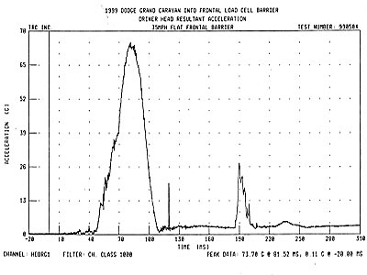
A graph of the head acceleration during a crash test
The graph above shows the acceleration of the driver's head during a 35 mph (56.3 kph) frontal crash. Notice that it is not a steady value, but fluctuates up and down during the crash. This reflects the way the head slows down during a crash, with the highest values coming when the head strikes hard objects or the airbag.
Load Sensors
Inside the dummy are load sensors that measure the amount of force on different body parts during a crash.
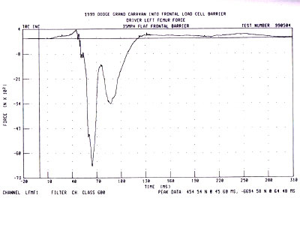
Photo courtesy NHTSA
A graph of the force in the driver's femur during a crash
The graph above shows the force in Newtons in the driver's femur (the thigh bone), during a 35-mph frontal crash. The maximum load in the bone can be used to determine the probability of it breaking.
Movement Sensors
These sensors are used in the dummy's chest. They measure how much the chest deflects during a crash.
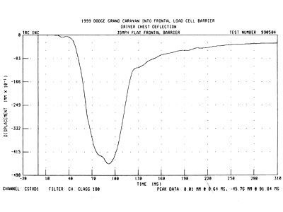
Photo courtesy NHTSA
The chest deflection during a 35-mph frontal impact
The scan above shows the driver's chest deflection during a crash. In this particular crash, the driver's chest is compressed about 2 inches (46 mm). This injury would be painful, but probably not fatal.
Now let's take a look at a real crash test.

An Actual Crash Test
The National Highway Traffic Safety Administration (NHTSA) conducts two types of crash tests as part of the New Car Assessment Program.
- 35-mph frontal impact - At 35 mph (56 kph), the car runs straight into a solid concrete barrier. This is equivalent to a car moving at 35 mph hitting another car of comparable weight moving at 35 mph.
- 35-mph side impact - A 3,015-pound (1,368-kg) sled with a deformable "bumper" runs into the side of the test vehicle. The sled's tires are angled. The test simulates a car that is crossing an intersection being sideswiped by a car running a red light. The sled actually moves at 38.5 mph, but when you do the math, it is equivalent to a 35-mph side impact because of the way the wheels on the sled are angled.

Photo courtesy NHTSA
Click on this image for a video of an actual crash test.
(Video time: 2 min, 33 sec)
Crash Test Paint
Before the crash-test dummies are placed in the vehicle, researchers apply paint to them. Different colors of paint are applied to the parts of the dummies' bodies most likely to hit during a crash. The dummy's knees, face and areas of the skull are each painted with a different color. In the following photo, you can see that the blue paint from the dummy's face is smeared on the airbag and that his left knee (painted red) hit the steering column.
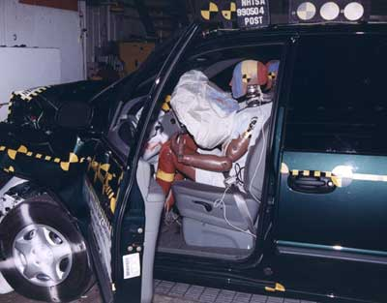
Photo courtesy NHTSA
The multicolored paint on the dummy shows where the different body parts hit the car.
If researchers note a particularly large acceleration in the data from the accelerometers in the dummy driver's head, the paint marks in the car will indicate what part of the body hit what part of the vehicle inside the cabin. This information helps researchers develop improvements to prevent that type of injury in future crashes.
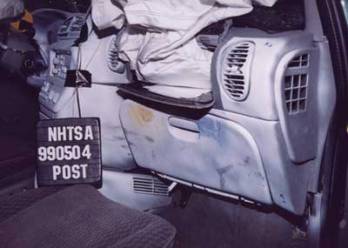
Photo courtesy NHTSA
The front passenger-side dummy's knees hit the dashboard during the crash. Also, note that nothing from the engine compartment penetrated the cabin. The engine on most cars is mounted so that in a crash, it is forced backwards and downward so that it won't come into the cabin.
Now, let's take a look at a 35-mph frontal-impact test.
Vehicle Setup
The photo below shows a van that is ready to crash. The dummies have been placed in the car and are in position. All of the instrumentation on the car and dummies has been hooked up and checked. Ballast is added to the car so that crash-test vehicle's weight -- and the distribution of that weight -- is equal to that of a fully loaded vehicle. A speed sensor has been mounted to the car and positioned so that it will pass through a pickup just as the car hits the barrier.
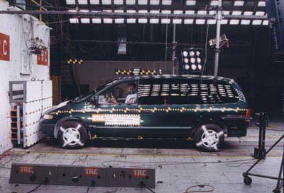
Photo courtesy NHTSA
A minivan in front of a barrier (note the camera's speed sensor)
There are 15 high-speed cameras, including several under the car pointed upward. They shoot around 1,000 frames per second. Next, the car is backed away from the barrier and prepared to crash. A pulley, mounted in a track, pulls the car down the runway. The car hits the barrier at 35 mph. It only takes about 0.1 seconds from the time the car hits the barrier until it stops.
After the Crash
Let's take a look at some pictures. This car got four stars for both occupants in this frontal-crash test.
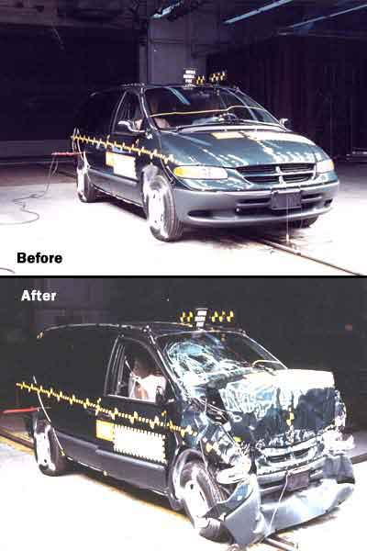
Photo courtesy NHTSA
The front of the same car, before and after the test
As you can see, the front of the car is completely crushed after the test. This is good, as the car has to get crushed and collapse in order to absorb the kinetic energy and stop the car.
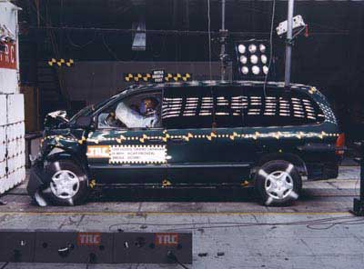
Photo courtesy NHTSA
A better view of the front crushing
The front of the van is crushed up to the front wheels, which are pushed back. In this crash, the van actually got 23 inches (58 cm) shorter!

The "Perfect" Crash
Obviously, the ideal crash would be no crash at all. But, let's assume you are going to crash, and that you want the best possible chances of survival. How can all of the safety systems come together to give you the smoothest crash possible?
Surviving a crash is all about kinetic energy. When your body is moving at 35 mph (56 kph), it has a certain amount of kinetic energy. After the crash, when you come to a complete stop, you will have zero kinetic energy. To minimize risk of injury, you would like to remove the kinetic energy as slowly and evenly as possible. Some of the safety systems in your car help do this.
Ideally, your car has seatbelt pretensioners and force limiters; they both tighten up the seatbelts very soon after your car hits the barrier, but before the airbag deploys. The seatbelt can then absorb some of your energy as you move forward towards the airbag. Milliseconds later, the force in the seatbelt holding you back would start to hurt you, so the force limiters kick in now, making sure the force in the seatbelts doesn't get too high.
Next, the airbag deploys and absorbs some more of your forward motion while protecting you from hitting anything hard.
In this hypothetical crash, the safety systems in the car all worked together to slow you down. If you didn't wear your seatbelt then the first stage of your protection is lost and it is going to hurt a lot more when you slam into the airbag. Many cars have seatbelt pretensioners and force limiters, but there are some even more exciting safety improvements coming.

Future Safety Improvements
It seems like air bags are sprouting from just about everywhere inside cars. And if they help keep your body from hitting hard objects during a collision, they're doing their job. But in the future, the emphasis on safety equipment will be to make it "smarter."
Eventually, we will see smart airbags that can deploy with different speeds and pressures, depending on the weight and seating position of the occupant, and also on the intensity of the crash. We'll see seatbelts that will also sense the weight and position of occupants and adjust the tension and maximum force accordingly.
Technology is enabling carmakers to design and manufacture safer, smarter vehicles, and consumers clearly endorse this trend as reflected in buying patterns. It may take wrecking lots of cars and crash test dummies, but the information gained from automotive crash tests means you and your loved ones may survive an automobile accident with little or no injury.

Background and Ratings
In recent years, cars have gotten much safer. One reason is that safety is now a selling point in new cars -- people actually seek out and buy safer cars. In the United States, the NHTSA crashes cars and analyzes data with a goal of improving car safety.
Carmakers themselves crash many vehicles each year. Car manufacturers are required to certify that their cars meet the Federal Motor Vehicle Safety Standards (FMVSS). These rules cover everything from how bright the turn signal bulbs must be to the crash-testing requirements. Carmakers have to be certain that if the NHTSA goes to any dealer in the United States, buys any car and crashes it at 30 mph, the car will pass all of the FMVSS requirements. To ensure that all of the different combinations of engines, transmissions and accessories will pass, carmakers might crash 60 to 100 vehicles themselves.
It is rare that a car fails the FMVSS requirements, so to challenge the carmakers even more -- and to provide valuable information to consumers buying cars -- the NHTSA started their New Car Assessment Program (NCAP). NCAP crashes cars at 35 mph (56 kph) in both frontal and side impact, and rates the cars based on how likely the occupants are to be injured during a crash. You can find the ratings online, a good first stop when looking for a new car.
What are my chances of being seriously injured?
This is a pretty tough question. In order to answer it, we have to define a serious injury. A lot of research has been done (and is still being done) to classify injuries. Crash-test researchers came up with a standard called the Abbreviated Injury Scale (AIS) for classifying different injuries. These same researchers published a manual that contains detailed descriptions of all the injuries normally found in car crashes. Each injury is assigned a rank based on how severe it was: 1 is just minor cuts and bruises; 3 indicates a serious injury that requires immediate medical treatment and may be life threatening; 6 is fatal.
Rating systems
Researchers have used crash test data to determine the likelihood of injuries that may be sustained in a crash. In addition, that data was used to create the NHTSA's star system. This system makes automobile safety ratings easier for consumers to understand when buying a car.
In frontal crashes, the star rating is determined by the worst score on these three criteria:
- Head Injury Criteria (HIC)
- Chest deceleration
- Femur load
In order to receive a five-star rating, all three of these criteria must be below the level that indicates a 10-percent chance of severe injury. There is a star rating for each of the front seat passengers, for each type of test that was run (frontal or side impact).
Ratings for Frontal-Impact Tests
# of Stars | Result
5 | 10% or lower chance of serious injury
4 | 11% to 20% chance of serious injury
3 | 21% to 35% chance of serious injury
2 | 36% to 45% chance of serious injury
1 | 46% or greater chance of serious injury
In side-impact crashes, there are two criteria:
- Thoracic Trauma Index (TTI)
- Lateral Pelvic Acceleration (LPA)
To achieve a five-star rating in side-impact crashes, both criteria must be in the range that indicates less than a 5-percent chance of serious injury.
Ratings for Side-Impact Tests
# of Stars | Result
5 | 5% or lower chance of serious injury
4 | 6% to 10% chance of serious injury
3 | 11% to 20% chance of serious injury
2 | 21% to 25% chance of serious injury
1 | 26% or greater chance of serious injury

